8-Puzzle Problem

AIM: To write a Python program to solve the 8-Puzzle Problem using an appropriate search algorithm.

Algorithm:
- Start the program.
- Initialize the initial state and goal state of the 8-puzzle.
- Represent the puzzle as a 3 × 3 matrix with one blank space.
- Generate all possible moves by moving the blank space up, down, left, or right.
- Apply a suitable search algorithm to explore the possible states.
- Continue until the goal state is reached.
- Display the solution path.
- Stop the program.
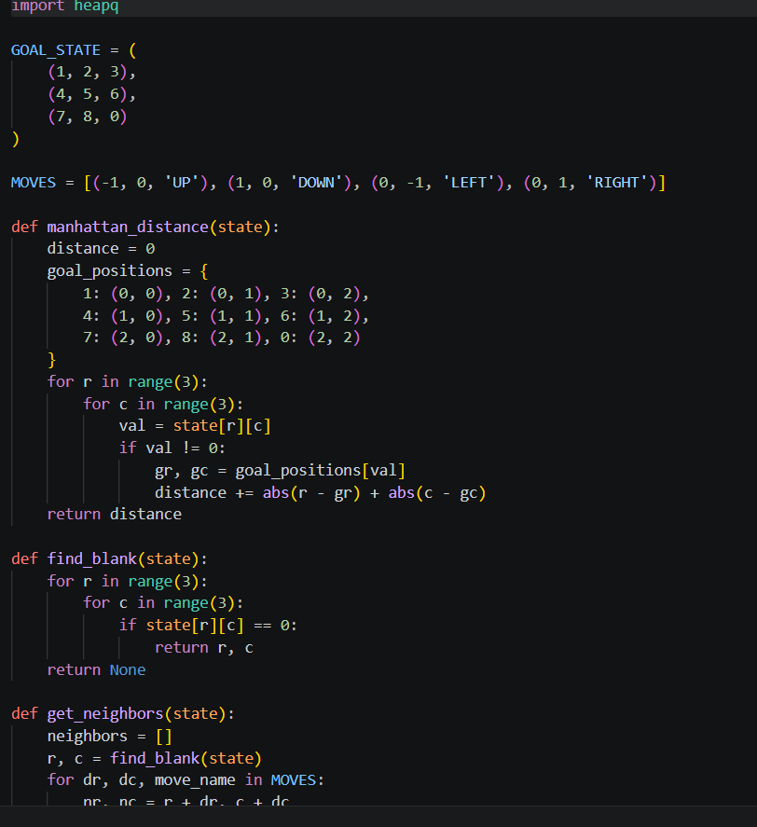
Code :

Output ;

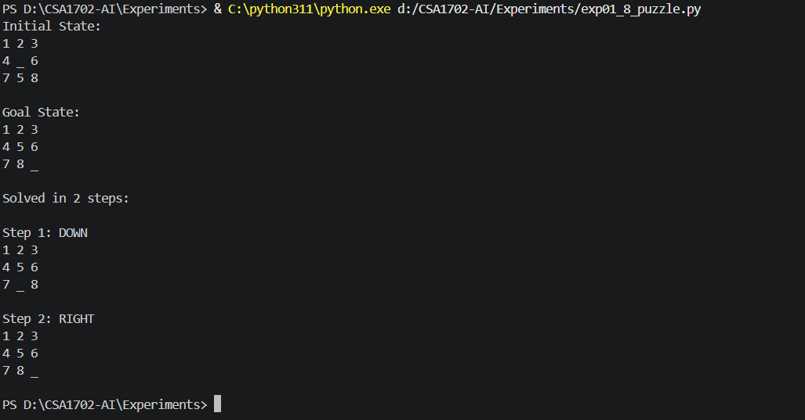
RESULT:

Thus, the Python program to solve the 8-Puzzle Problem was executed successfully.

